Embedded Power BI Desktop Solution into Web App

# Overview

## The estimated time to complete the lab is 20 minutes

In this lab, you will create Power BI Embedded service in azure portal and embed a Power BI Desktop solution into Web app.

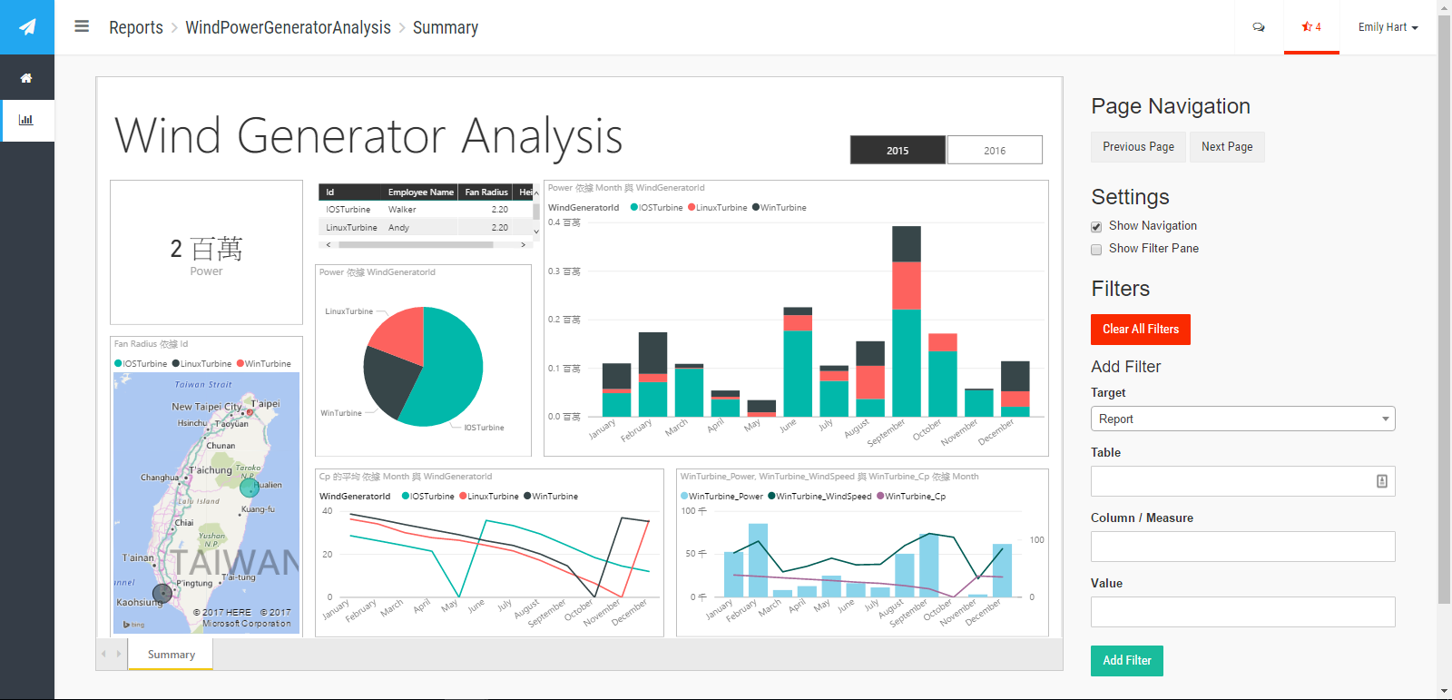

Environment requirement:

* .pbix file
* Git
* Azure Subscription
* Visual Studio

You will learn how to:

* Provision Power BI Embedded service
* Clone Power BI sample code from GitHub
* Embed Power BI Desktop solution into Web App

# Stage 1

## Provision Power BI Embedded on Azure

1. To open the Azure portal, click “+” button then find Power BI Embedded in Marketplace**.**

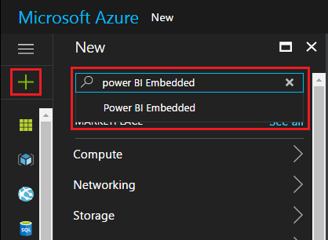

1. Select **Create**

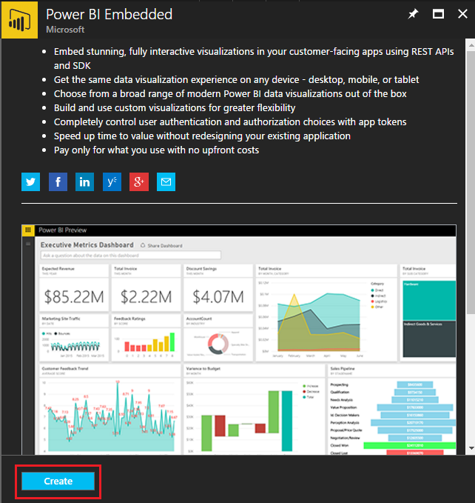

1. Configure the Power BI Embedded setting & select Create.

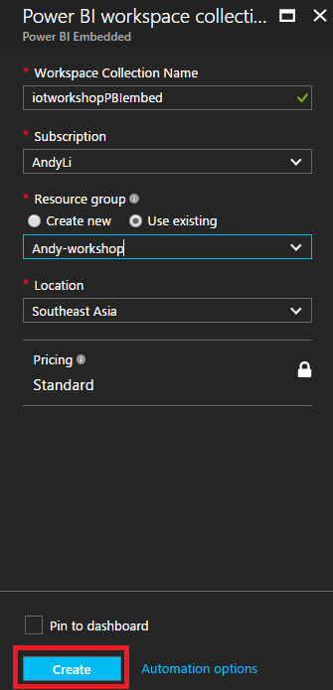

1. Find and click Power BI Embedded from resource group you specify before.

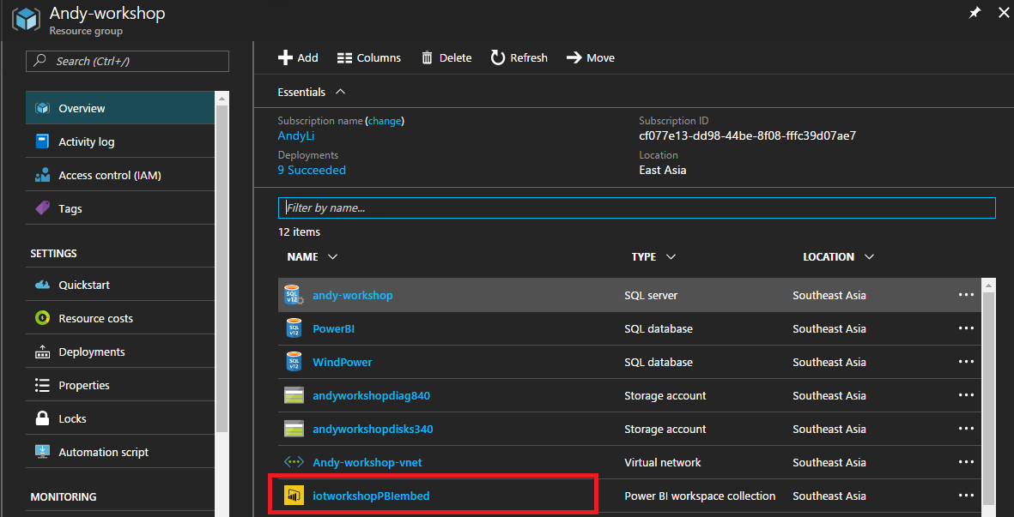

1. Find and **Take note** for the workspace collection **Name**

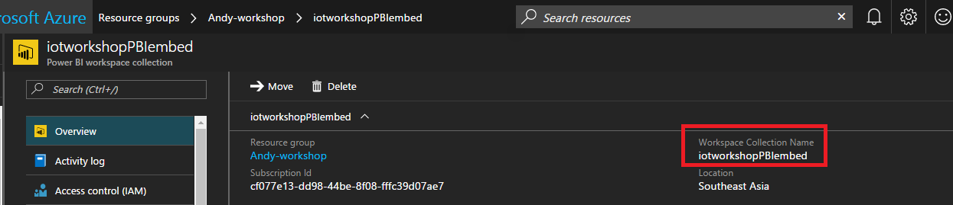

1. Click **Access keys** and **take note** for the workspace collection **Key**.

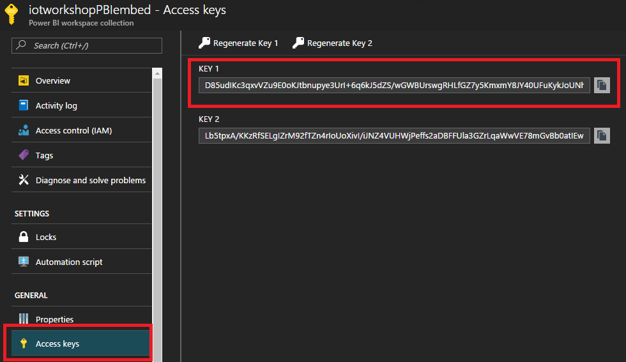

## Clone Power BI Embedded Sample

1. Go to [**Power BI Embedded – Integrate a report into a web app**](https://github.com/Azure-Samples/power-bi-embedded-integrate-report-into-web-app/) on GitHub.
2. Click **Clone or download** button and copy clone web URL.

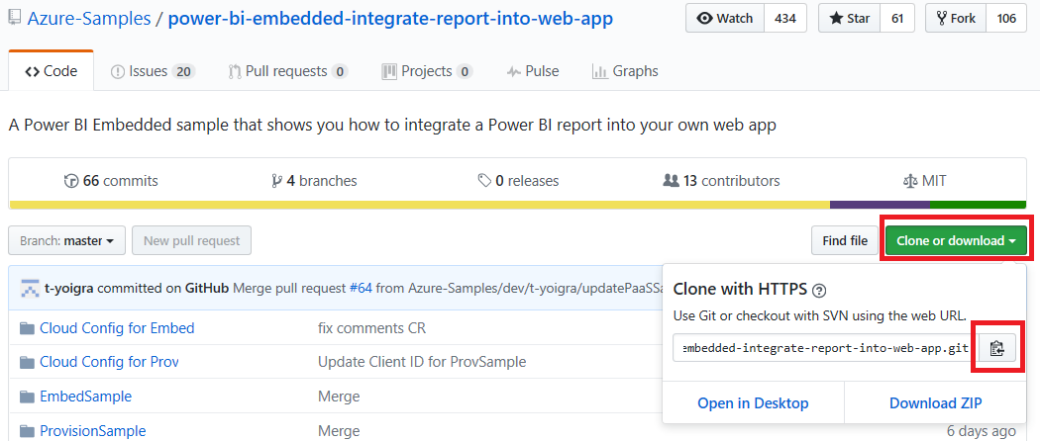

1. Open Git and paste **cd My Documents/Visual Studio 2015/Projects/**
2. Paste **git clone --recursive https://github.com/Azure-Samples/power-bi-embedded-integrate-report-into-web-app.git**

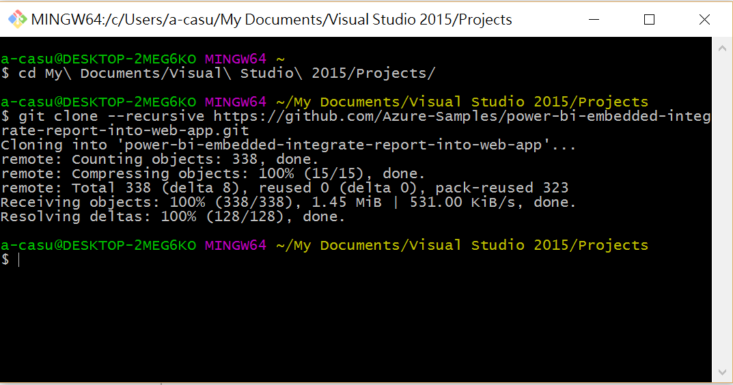

## Embed Power BI Desktop Solution into Web App

1. Open **PowerBI-embedded.sln** in Visual Studio & build project (CTRL+SHIFT+B)

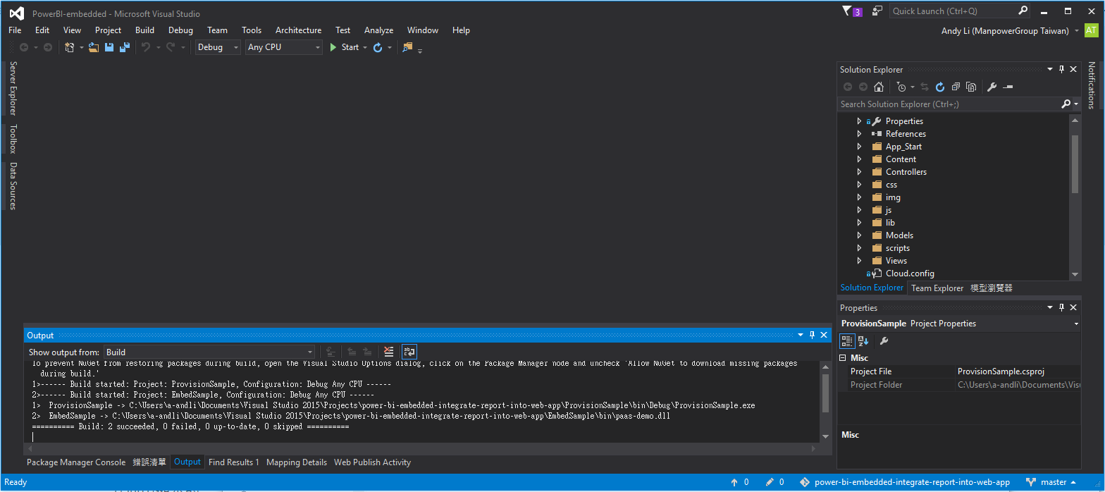

1. Right click **ProvisionSample** in Solution Explorer, then click **Set as StartUp Project**.

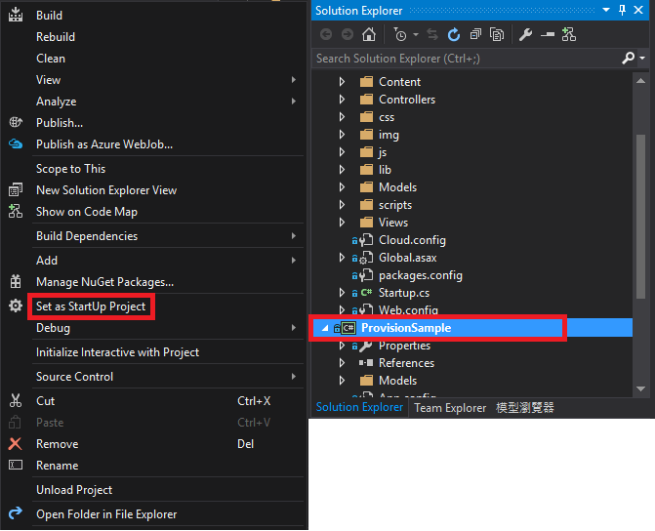

1. Run the solution (F5), then enter 1.

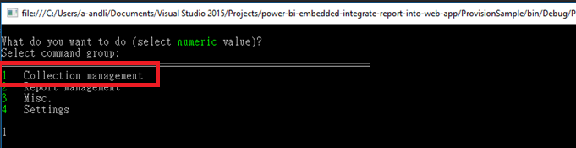

1. Enter 6 to provision a new **Workspace** in an existing workspace collection.

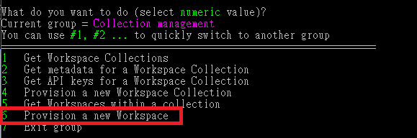

1. Enter **workspace collection name**, **workspace name** and **Access Key** in the console.

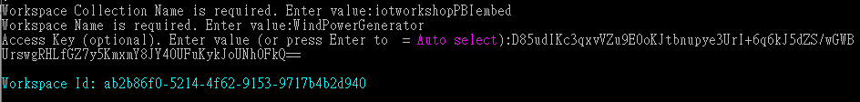

1. Take note for the **workspace ID** previous step generated, then enter 7 to exit group.
2. Enter 2 in **Report management**, then enter 3 to **import PBIX Desktop file into a workspace**.

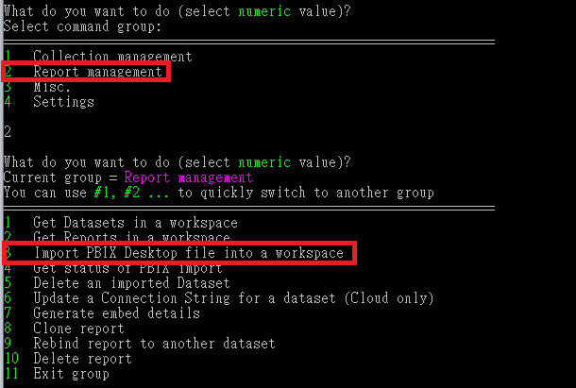

1. Enter, enter and enter Dataset Name **WindPowerGeneratorAnalysis**.
2. Enter pbix path : **~\07-HOL\Wind Power Generator Analysis.pbix**

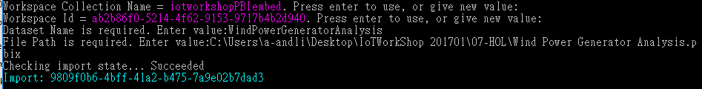

1. Open **Web.config** from **EmbedSample** project and add **AccessKey, WorkspaceCollection, WorkspaceId to Web.config.**

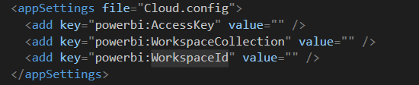

1. Right click **EmbedSample** in Solution Explorer, then click **Set as StartUp Project**.

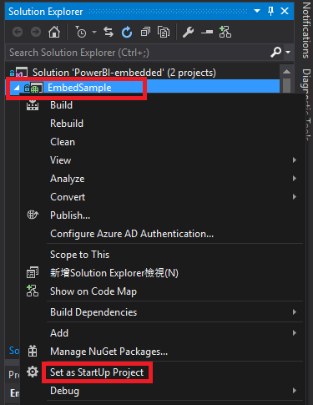

1. Run the solution (F5), the sample web app will be run locally and You can see your embedded report from the side bar.

